**Ideation Phase**

**Define the Problem Statements**

|  |  |
| --- | --- |
| Date | 19 September 2022 |
| Team ID | PNT2022TMID10625 |
| Project Name | Online Organic store management |
| Maximum Marks | 2 Marks |

**Customer Problem Statement Template:**

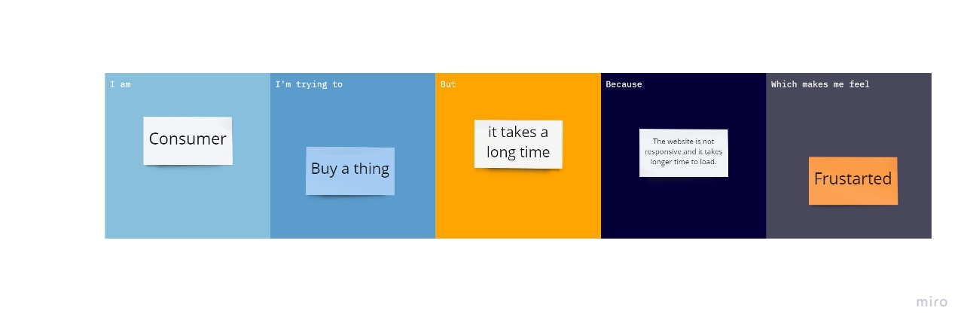

Customer

Frustrated

Open page

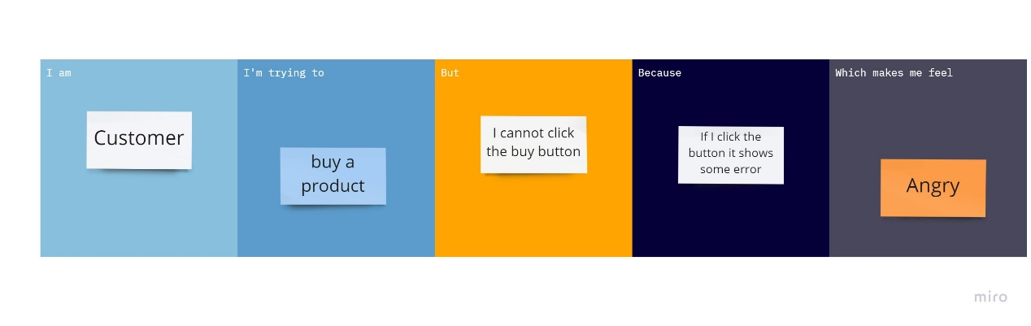

Customer

If I click the button, it shows, select

Click buy button

Buy a Product

Good

|  |  |  |  |  |  |
| --- | --- | --- | --- | --- | --- |
| **Problem Statement (PS)** | **Iam (Customer)** | **I’m trying to** | **But** | **Because** | **Which makes me feel** |
| PS-1 | Costumer | Buy a thing | It takes a long time | The website open | Frustrated |
| PS-2 | Costumer | Buy a Product | click the buy button | If I click the button it shows select | Good |